AWS Lambda Layer for Matrix Transposition

1.first we wite code for lambd_function

Write a Python function named `transpose_matrix` that accepts a 2D list (matrix) of numbers and returns its transpose. ■ The transpose of a matrix is achieved by flipping a matrix over its diagonal, switching the row and column indices of the matrix

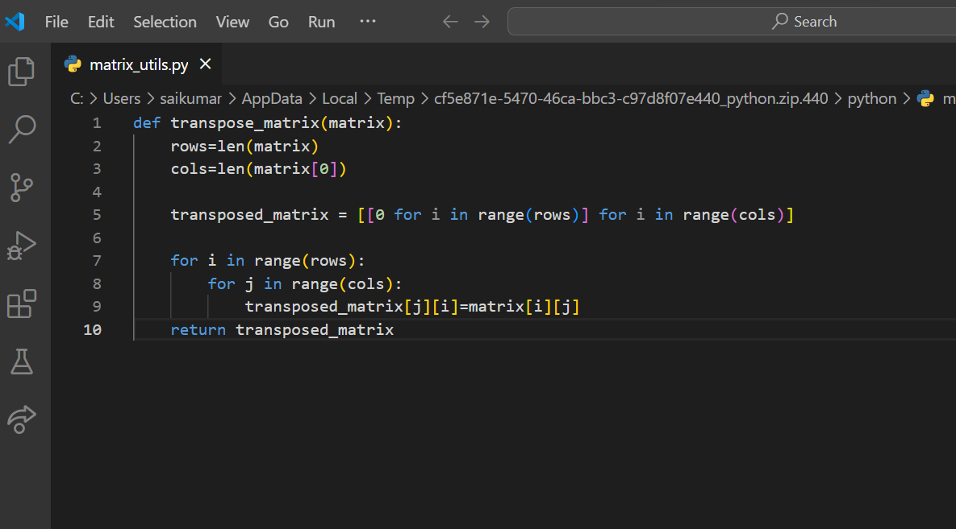

2 .next will create a Python file named `matrix_utils.py` and include your `transpose_matrix` function within this file

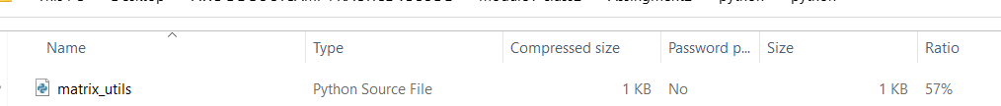

3 . next we will keep matrix_utils.py in python and we will zip it.

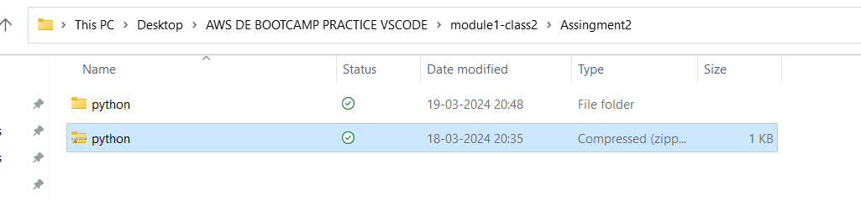

4.next ● Task : Create the Lambda Layer ○ Instructions: ■ In the AWS Management Console, navigate to Lambda and choose "Layers" from the sidebar. ■ Click "Create layer," name your layer (e.g., `matrix-transpose-layer`), and upload the ZIP file you prepared. ■ Select the compatible runtime for your Lambda function (matching the Python version used). ■ Note the ARN of the created layer upon completion

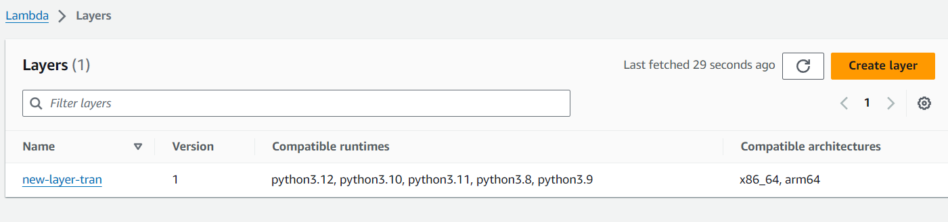

5 next will create ● Create a New Lambda Function ○ Instructions: ■ Create a new Lambda function (e.g., `TransposeMatrixFunction`) from the AWS Management Console. ■ Choose the same Python runtime as used for the Lambda Layer. ■ In the function code, import `matrix_utils` and write a handler that invokes `transpose_matrix` with a matrix provided in the event data.

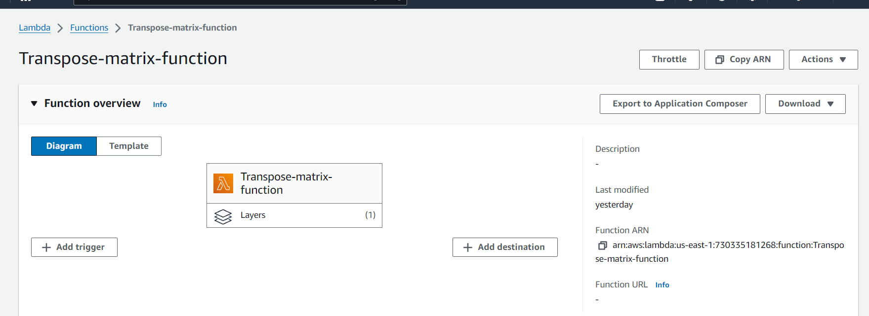

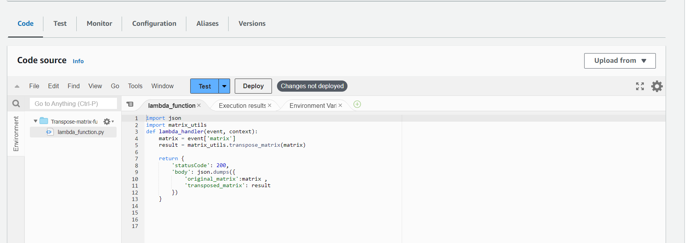

6.Next ● Task : Add the Lambda Layer to Your Function ○ Instructions: ■ In the Lambda function configuration, under "Layers," choose "Add a layer." ■ Select "Custom layers" and choose the layer you created previously. ■ Add the layer to your function

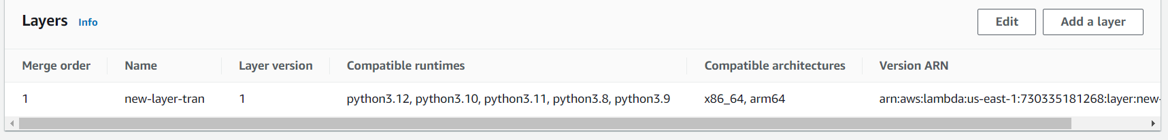

7.Next Task: Test Your Lambda Function ○ Instructions: ■ Configure a test event in the Lambda console with a sample 2D matrix as the input 🡪In test event create new event

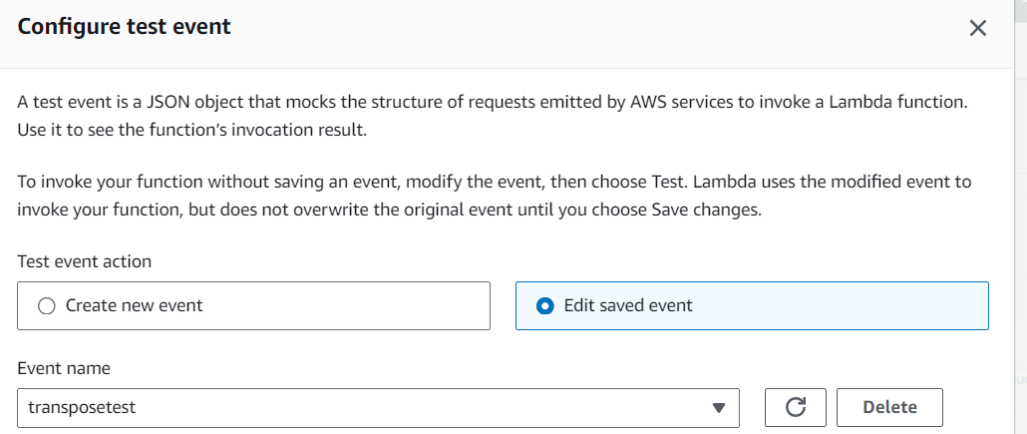

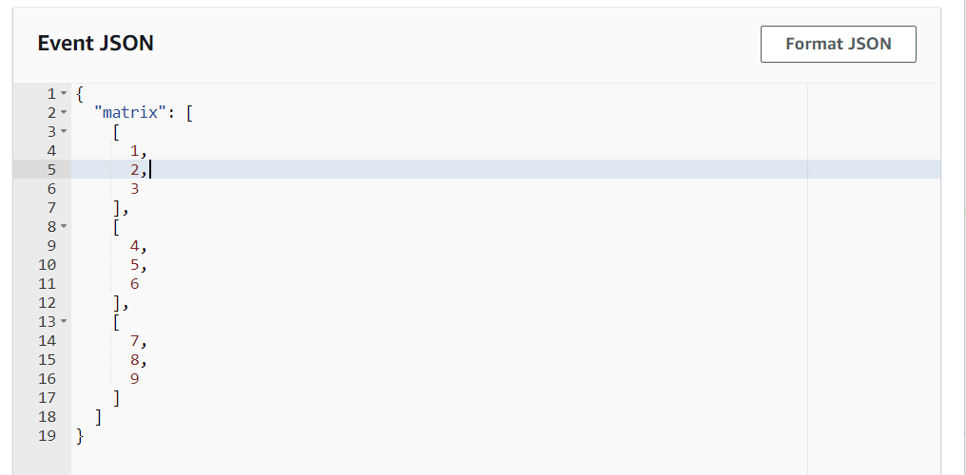

* After testing

